1.Creating project directory

Create html, CSS, JavaScript for your website and a dockerfile in a single folder(weather_app).

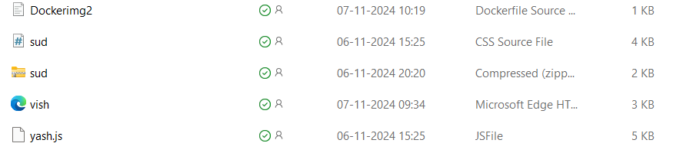

*Image: project directory*

Content of Dockerimg2.dockerfile:

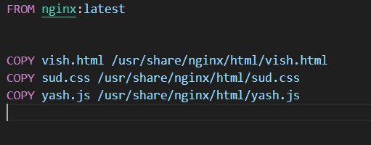

*Image:Dockerimg2.dockerfile*

It will import the NGINX default image.

COPY command will copy files into default image .

2. Building docker image

Open command prompt.

**Enter to your folder directory** By using cd.

Then give the following command:

***docker build -f Dockerimg2.dockerfile -t weather_app_image .***

Dockerimg2.dockerfile : your docker file name.

weather_app_image : docker image name.

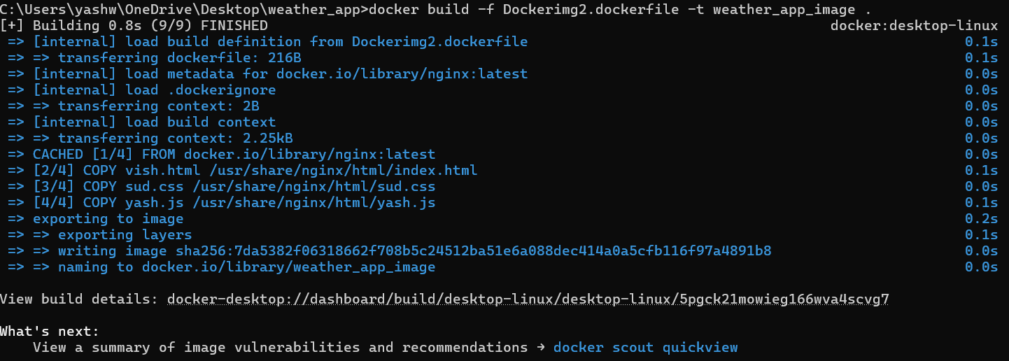

*image:* *docker build -f Dockerimg2.dockerfile -t weather_app_image . command*

3.Running the docker image

After building the docker image, run the following command.

***docker run -p 8081:80 weather_app_image***

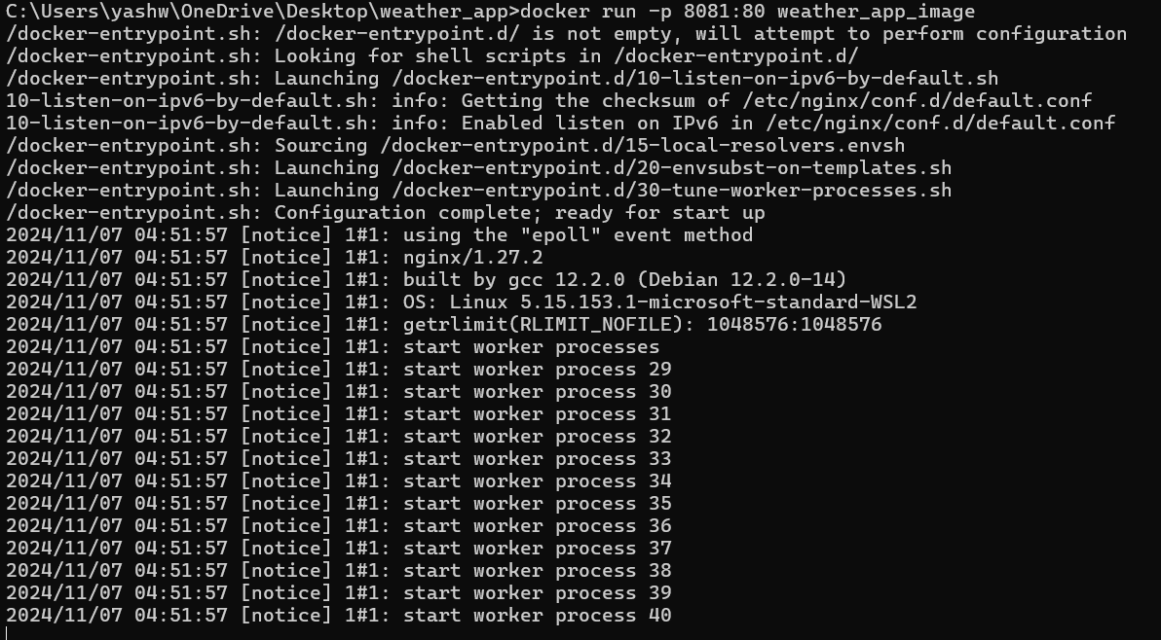

*Image:* *docker run -p 8081:80 weather_app_image command*

Here, we are using the port 8081 for this application to run.

Access your web application through **http://localhost:8081**